Paper Title
Georgian Geographical Journal, 2024, 4(1) 1-15
© The Author(s) 2024

This article is an open access article distributed under the terms and conditions of the Creative Commons Attribution (CC BY) license (https:// creativecommons.org/licenses/by/ 4.0/).
DOI:
https://journals.4science.ge/index.php/GGJ
Name Surname^{1,*}, Name Surname²
¹ Department, University, City, Country
² Department, University, City, Country
³ Department, University, City, Country
^{* Corresponding author: e-mail}
Citation: Zhang, L.; Jimenez, A.;
Ordeñana, X.; Choi, S. Corporate
Decision on Digital Transformation:
The Impact of Non-Market Factors.
Georgian Geographical Journal 2024, 15, 16628.
https://doi.org/10.3390/
su152416628

Received: 9 November 2023
Revised: 22 November 2023
Accepted: 5 December 2023
Published: 7 December 2023
Abstract
A single paragraph of about 200-400 words, no figures, no photos, no tables, no formulas, no subsections, no references (TNR, 10 pt., Justified). The following items should be included: Context/Purpose: One to two sentences explaining why you studied this particular topic and what is significant about it. Has previous research been conducted? What is the contribution of your research to the current body of knowledge? Approach: Simply describe the methodologies chosen to carry out the research. What method did you employ to gather your data? What method did you use for analysing your data? Findings: A concise summary of the discoveries made during the research process, consisting of three to four phrases. Analysis: Provide a concise explanation of the results in no more than four sentences. What is the significance of the results? In conclusion, I have derived a concise and significant statement that encapsulates the knowledge gained from my research and highlights its significance.
Keywords: 4-6 words or phrases, separated by commas and not to exceed 2 lines

Introduction
The Introduction section clarifies the motivation for the work presented and prepares readers for the structure of the paper. Begin by offering a background to acquaint readers who may have limited knowledge about your subject matter and to emphasise the significance of your research.
Furthermore, articulate the necessity for your research by highlighting the disparity between the existing state of affairs within the scientific community and its desired condition.
Thirdly, identify the actions you have taken in order to tackle the requirement (this is the assignment).
Conclude by providing readers with a preview of the remaining sections of the work, aiming to psychologically prepare them for its overall structure and purpose.
Introduction should provide main context of the paper (TNR; 11 pt; Spacing: Single; Justified). Paper size: A4. References should be cited in the text as (Schwab et al., 1993). In case of several reference (Salukvadze & Golubchikov, 2016; Zhao et al., 2019).
Methods and Materials
Section provides sufficient detail for other scientists to reproduce the experiments presented in the paper. In some journals, this information is placed in an appendix, because it is not what most readers want to know first.
This part of the paper includes the study area too. All tables should be editable (avoid image files). The title should be written above the table.
Papers reporting something other than experiments, such as a new method or technology, typically have different sections in their body, but they include the same Introduction and Conclusion sections as described here.
Study Area (optional)
Results
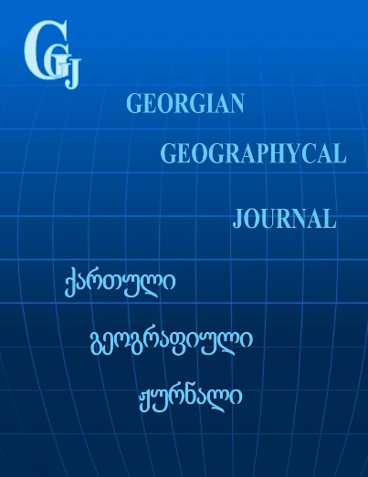
All figures and tables should be cited in the main text as Fig. 1, Table 1, etc. All figures and photos should be in Tiff or JPG file with high resolution (no less than 300 dpi).
Figure 1. Georgian Geographical Journal
The title should be below the figure, outside of it and be editable (avoid image files). If there are multiple panels authors are encouraged to use the example below.
Table 1. Georgian Geographical Journal
 | Data | Data | Data | Data
Table | 1 | 2 | 3 | 4
Table | 5 | 6 | 7 | 8
Table
Table

All formulas should be according to the template shown below, the numbers should be put in brackets after each formula, no image format. Formula must be typed in Math Type equation editor.
All formulas should be according to the
$a^{2}+b^{2}=c^{2}$ (1)
Section name (optional)
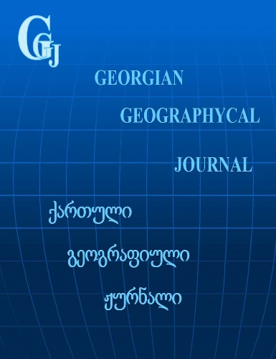

Author(s) can divide the resalt section into the subsections.
Figure 2. Georgian Geographical Journal

Discussions
Authors should discuss the results in the broadest context possible.
Conclusion
The Conclusion section presents the outcome of the work by interpreting the findings at a higher level of abstraction than the Discussion and by relating these findings to the motivation stated in the Introduction. Papers without conclusion won’t be accepted.
Competing interests
The authors declare that they have no competing interests.
Authors’ contribution
A.B. and C. D. conceived of the presented idea. L.G. and I. K. performed the analytic calculations. E.F. took the lead in writing the manuscript. All authors provided critical feedback and helped shape the research, analysis and manuscript.
Acknowledgements
The authors thank the…. Special thanks go to… from The University of… for their exceptional support towards…
Funding
This research [] has been supported by….
ORCID iD
Name Surnamehttps://orcid.org/0000-0000-0000-0000
Name Surnamehttps://orcid.org/0000-0000-0000-0000
Reference
Salukvadze, J., & Golubchikov, O. (2016). City as a geopolitics: Tbilisi, Georgia - A globalizing metropolis in a turbulent region. Cities, 52. https://doi.org/10.1016/j.cities.2015.11.013
Schwab, G. O., Fangmeier, D. D., Elliot, W. J., & Frevert, R. K. (1993). Soil and water conservation engineering. 4th edition. Soil and Water Conservation Engineering. 4th Edition.
Zhao, L., Tang, Z. Y., & Zou, X. (2019). Mapping the knowledge domain of smart-city research: A bibliometric and scientometric analysis. Sustainability (Switzerland), 11(23). https://doi.org/10.3390/su11236648

